
Tertiary Infotech Academy Pte Ltd
UEN: 201200696W
LEARNER GUIDE
For
Customer Service Masterclass
Course Code: C529
Conducted by
Tertiary Infotech Academy Pte Ltd
UEN: 201200696W
Version 1.0

DOCUMENT VERSION CONTROL RECORD
Version Number | Effective Date of Release | Summary of Included Changes | Author
1.0 | 28 September 2026 | Initial release. Nine topics and nine case-study activities across two learning units, delivered in one day (9:30am – 5:30pm). | Dr. Alfred Ang

TABLE OF CONTENTS

Introduction 4
How to Use This Guide 4
Course Learning Outcomes 4
Topic 1 — Understanding Customers & Customer Service 4
Activity 1 — Mapping the Service Chain at a Singapore Bank Branch 5
Topic 2 — Establishing Your Service Attitude 7
Activity 2 — Attitude and Positive Language at a Changi Airport Service Counter 8
Topic 3 — Identifying and Addressing Customer Needs 10
Activity 3 — Diagnosing Customer Needs at a Growing SME — TechNova Account Review 12
Topic 4 — In-Person Customer Service 14
Activity 4 — The Walk-In Interruption — Retail Service Counter, Bugis 15
Topic 5 — Customer Service Over the Phone 17
Activity 5 — The Angry Delivery Call — Logistics Hotline 17
Topic 6 — Customer Service via Email and Chat 19
Activity 6 — Rewriting the Refund Email — E-Commerce Support Inbox 21
Topic 7 — Generating Return Business from Feedback 23
Activity 7 — Closing the Loop — F&B Chain Losing Repeat Customers 26
Topic 8 — Recovering Difficult Customers 29
Activity 8 — Service Recovery Under Pressure — The Wedding Catering Failure 29
Topic 9 — Understanding When to Escalate 32
Activity 9 — Drawing the Line — Escalation and Abuse at a Service Counter 33
Common Service Pitfalls to Avoid 36
Quick Reference — The Frameworks in This Course 36
Glossary 37

Introduction
This Learner Guide accompanies the course Customer Service Masterclass (C529), conducted by Tertiary Infotech Academy Pte Ltd. It covers all nine topics across the two learning units, and gives the full step-by-step instructions for all nine case-study activities you will complete in class.

How to Use This Guide
- Read the topic section before its activity — the concepts are what the activity asks you to apply.
- During each activity, work from the Step-by-step section. The slides show only the scenario and the discussion questions; the detailed procedure lives here.
- After each activity, read the Debrief section. It states what a strong answer looks like.
- The 'Check your work' line at the end of every activity is your self-check standard.
- This guide is your reference during and after the course — keep it handy.
- A printable one-page brief for each activity is in the activities folder (activities/activity-NN/).

Course Learning Outcomes
- LO1: Collect and analyse customer feedback to assess needs and expectations using effective communication principles.
- LO2: Identify and recommend areas for improvement based on customer feedback and operational insights.

Topic 1 — Understanding Customers & Customer Service
Who customers are · what service is · who provides it · the service-profit chain
Learning unit: LU1 · 45 min
Key concepts
- Service is every interaction — Customer service is the whole of the support a customer receives before, during and after a purchase — not just the complaint desk.
- External and internal customers — External customers buy from you; internal customers are colleagues who depend on your output. Both are served.
- Service quality is a chain — Internal support enables frontline delivery, which shapes customer experience, which drives loyalty and revenue.
- Service is a growth centre — Help Scout: great service is a growth centre, not a cost centre — retention, referral and lifetime value all flow from it.
- The cost of getting it wrong — 86% of customers stop buying after poor experiences; US firms lose over US$62 billion a year to bad service (Help Scout).
- Four principles of good service — Help Scout: service must be personalised, competent, convenient and proactive — all four, or the experience breaks.
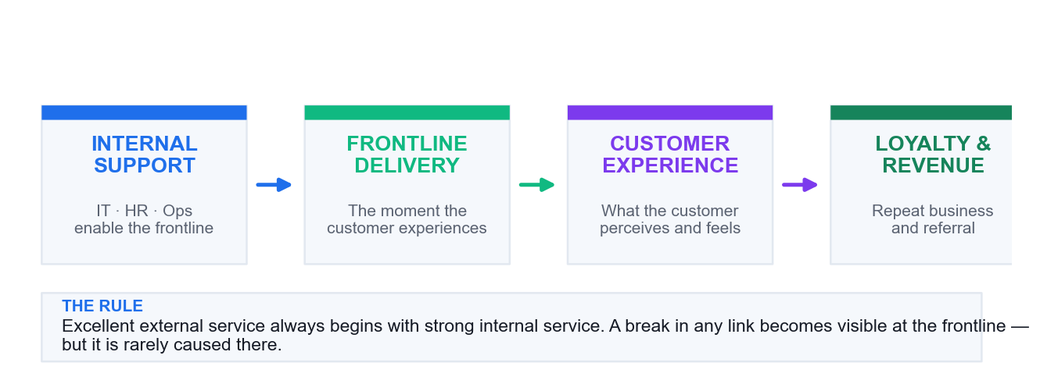
The service chain — a break anywhere upstream surfaces as a frontline failure.
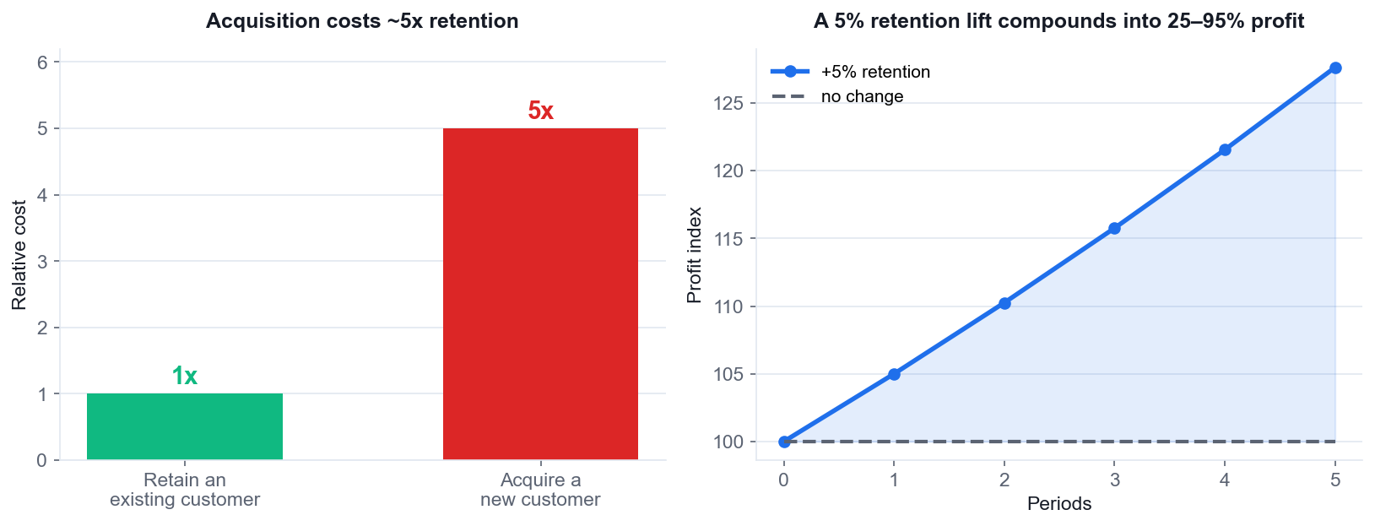
Why service pays: acquisition costs about 5x retention, and retention compounds.

Activity 1 — Mapping the Service Chain at a Singapore Bank Branch
Mapping: LO1 · Understand internal vs external customers and how the service chain shapes experience.
Format: Case Study + Peer Sharing · Duration: 25 minutes · Groups of 4–5. Each group maps the chain; one member presents.
Scenario
OCBC-style retail branch, Tampines. Mdm Rohani, 68, comes in to reactivate a dormant savings account so her CPF payout can be credited. The queue ticket says 12 minutes; she waits 47. At the counter, the teller, Wei Ming, finds the reactivation needs a signature-verification form that Operations must approve. Operations is understaffed and quotes 3 working days. Wei Ming has no authority to expedite and no way to see the Operations queue. Mdm Rohani has already made two trips. She says loudly that she will move her account to another bank, and other customers in the queue are listening.
Behind the counter: the branch manager has a service-level dashboard showing counter wait times but not back-office turnaround. Operations measures forms processed per day, not customer trips avoided. The digital team launched an app-based reactivation two months ago that nobody told the branch about.
What you will produce
A service-chain map naming every internal and external customer, the broken link, and one fix per link. (Materials: Whiteboard / flip chart · Service chain worksheet.)
Discussion questions
1. Who are the EXTERNAL customers in this case, and who are the INTERNAL customers? List every one.
2. Draw the service chain from Mdm Rohani's need to the outcome she actually got. Where exactly did it break?
3. Wei Ming was polite and followed procedure, and the customer still left angry. Whose service failure is this?
4. Operations measures 'forms processed per day'. What behaviour does that metric produce, and what does it miss?
5. The app-based reactivation existed but the branch did not know. What internal service failure does that reveal?
6. Name one change per link in the chain that would have prevented this outcome.
Step-by-step
1. Form groups of 4–5. Read the case aloud once as a group so everyone shares the same facts.
2. On a flip chart, draw two columns: EXTERNAL CUSTOMERS and INTERNAL CUSTOMERS. List every person or team in the case under the right column. Mdm Rohani is external — but so are the customers in the queue who overheard.
3. Draw the service chain left to right as boxes: Mdm Rohani's need → queue system → Wei Ming (teller) → Operations → outcome. Add the branch manager and digital team as boxes that FEED the chain from above.
4. On each arrow between boxes, write what is supposed to flow (information, authority, approval). Then mark with a red X every arrow where that flow failed.
5. For each red X, write the internal customer whose need was not met. Example: the arrow from Operations to Wei Ming should carry 'queue visibility' — it carries nothing, so Wei Ming's need as an internal customer is unmet.
6. Answer discussion question 4 explicitly: write the behaviour 'forms processed per day' rewards, and write what it makes invisible.
7. Agree ONE fix per broken link. Write each fix as a specific action with an owner, not a slogan — 'give tellers read access to the Operations queue dashboard', not 'improve communication'.
8. Nominate a presenter. Present the map in 2 minutes: the chain, the breaks, and your fixes.
Debrief — what a strong answer looks like
- The frontline is where the failure BECOMES VISIBLE, not where it is caused. Wei Ming did nothing wrong — he was set up to fail by the links behind him.
- Internal customers here: Wei Ming is Operations' customer; the branch is the digital team's customer; Operations is the branch manager's customer. Every one of those relationships failed.
- 'Forms processed per day' optimises throughput, not resolution. It is blind to Mdm Rohani's THREE trips — the metric would look healthy while the customer churns.
- The undisclosed app feature is a pure internal-communication failure. A capability the frontline does not know about does not exist.
- Expected fixes: give the teller visibility of the Operations queue; give SOMEONE authority to expedite; measure customer trips not forms; brief the branch on every new digital capability.
- Link back to Topic 1: excellent external service always begins with strong internal service. This case is the proof.
Check your work
Your map names at least 3 internal customers, marks at least 3 broken links, and each fix is a specific action with an owner.
Note: A printable one-page brief for this activity is in activities/activity-01/.

Topic 2 — Establishing Your Service Attitude
Appearance · the power of a smile · staying energised · staying positive · positive language
Learning unit: LU1 · 45 min
Key concepts
- Attitude is visible instantly — First impressions form in 4–7 seconds; roughly 55% of that impression comes from appearance and body language.
- Emotions are contagious — Your mood transfers to the customer. A genuine smile measurably raises trust and how welcome a guest feels.
- Positive language reframes limits — 'That's back-ordered' becomes 'That's available next month — I can reserve it now.' Same fact, different outcome.
- Energy must be managed — Service quality decays with fatigue. Structured micro-breaks and shift resets protect the last customer of the day.
- Resilience is a trained skill — Zendesk lists resilience as core: absorbing criticism without letting it degrade the next interaction.
- Professionalism is the baseline — Respectful tone, accuracy and appropriate boundaries held consistently — regardless of how the customer behaves.
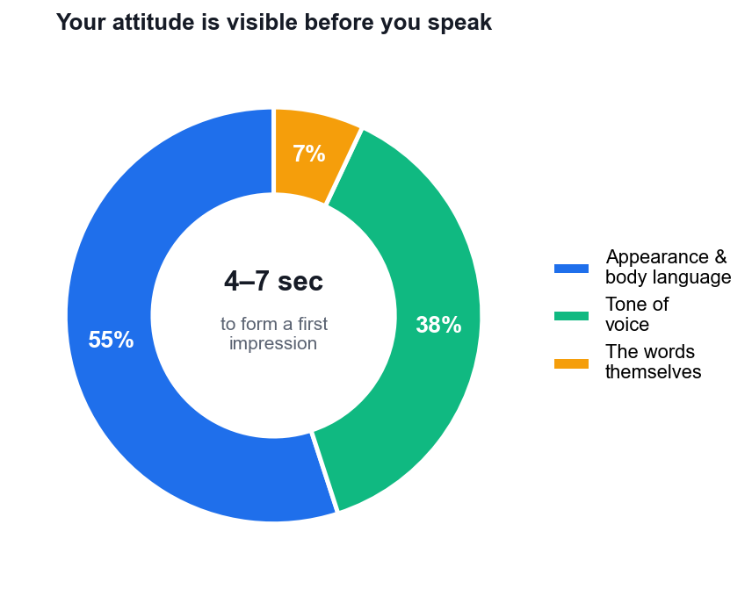
First impressions form in 4–7 seconds, mostly from what the customer sees and hears.

Activity 2 — Attitude and Positive Language at a Changi Airport Service Counter
Mapping: LO1 · Apply service attitude, body language and positive language under pressure.
Format: Role Play + Peer Sharing · Duration: 15 minutes · Pairs. Role A = Service Officer, Role B = Mr Krishnan. Swap after the first round. Observers score.
Scenario
Changi Airport Terminal 3, airline transfer desk, 11:40pm. Mr Krishnan and his two children (aged 4 and 7) have missed their connecting flight to Chennai because the inbound flight was delayed by weather. The next available flight is 14 hours away. Company policy for weather delays: no hotel accommodation, no meal vouchers, rebooking only. The children are crying. Mr Krishnan has been queueing for 35 minutes and is the eleventh passenger you have seen with the same problem tonight. You are 90 minutes past the end of your shift.
What you CAN do: rebook him on the 1:50pm flight; give him lounge access at your discretion; provide a transit hotel booking form at his own cost; escalate to the duty manager for a goodwill exception.
What you will produce
A rewritten positive-language script and a 5-minute role play that delivers a 'no' without losing the customer. (Materials: Positive language worksheet · Observer checklist.)
Discussion questions
1. Rewrite each phrase in positive language: 'We don't cover weather delays.' / 'There's nothing I can do.' / 'You'll have to pay for that yourself.' / 'That's not our policy.' / 'I don't know.'
2. You are 90 minutes past your shift end and this is the eleventh identical case. How does that show up in your body language and voice, even when your words are correct?
3. The answer to 'will you pay for my hotel?' is genuinely no. How do you say no and still leave the customer feeling served?
4. What can you offer that costs the company little but changes how Mr Krishnan experiences this? Name three things.
5. At what point, if any, would you escalate to the duty manager — and what would you say to Mr Krishnan as you do it?
6. The two crying children are not your customer, but they change the interaction. How?
Step-by-step
1. Individually, rewrite the five negative phrases from discussion question 1 into positive language. Write both versions side by side so the contrast is visible.
2. Compare with your partner. Keep the strongest rewrite of each pair. A good rewrite states what you CAN do and never begins with 'unfortunately' or 'we don't'.
3. Assign roles: A = Service Officer, B = Mr Krishnan. B, read only the customer half of the brief — you are exhausted, your children are crying, and you believe the airline owes you a hotel.
4. Before starting, A checks their own physical setup: shoulders back, hands visible, eye contact ready, a breath in before the first word. This is the attitude reset from Topic 2.
5. Run the role play for 5 minutes. A must deliver the 'no' on hotel accommodation within the first 2 minutes — do not delay it to seem helpful, that is worse.
6. Observers mark the checklist: Did A greet and acknowledge within seconds? Did A acknowledge the children? Did A use positive language? Did A offer alternatives before being asked? Did A state clear next steps?
7. Debrief in the pair for 2 minutes: B says how the 'no' actually felt to receive, which is the only score that matters.
8. Swap roles and run the scenario again. The second Officer must use at least two techniques they saw work in round one.
Debrief — what a strong answer looks like
- Positive language does not mean saying yes. It means directing the customer to what IS available: 'I can get you on the 1:50pm and into the lounge now' beats 'we don't cover weather delays' with the same underlying answer.
- 'I don't know' becomes 'let me find out' — the second is the same information plus ownership.
- Fatigue leaks through the non-verbal channel first. Words stay professional long after tone and posture have given up. Observers should watch for flat tone, no eye contact, and a sigh before speaking.
- The three low-cost offers most groups find: lounge access (comfort for the kids), a proactive rebooking done before he asks, and a printed confirmation so he does not have to re-explain at the next desk.
- Acknowledge the children explicitly — the customer's stress is mostly about them. Serving the parent means noticing the kids.
- Escalation here is not defeat: naming the duty manager and saying 'I want to ask if we can make an exception for you' shows the customer you are on their side of the counter.
Check your work
You delivered a genuine 'no' inside 2 minutes, offered at least two alternatives unprompted, and your partner reports feeling served rather than dismissed.
Note: A printable one-page brief for this activity is in activities/activity-02/.

Topic 3 — Identifying and Addressing Customer Needs
Active listening · questioning · the four levels of need · going the extra mile
Learning unit: LU1 · 60 min
Key concepts
- Needs are functional and emotional — The product must work (functional) and the customer must feel valued (emotional). Missing either loses the customer.
- Active listening is the core skill — Attend fully, paraphrase back, read the cues, then confirm. Only 17% of customers believe businesses actually listen (Tidio).
- Ask before you prescribe — Open questions surface the real need; closed questions confirm it. Diagnosing before solving prevents the wrong fix.
- Attentiveness reads the unsaid — Repeated 'I couldn't find it' across customers is a UX defect report, not a series of individual questions.
- Four levels of addressing needs — Understand the problem → meet the basic need → think outside the box → go the extra mile.
- Personalisation drives loyalty — Use history and context; 35% would rather deal with an AI than repeat themselves to a human (Salesforce).
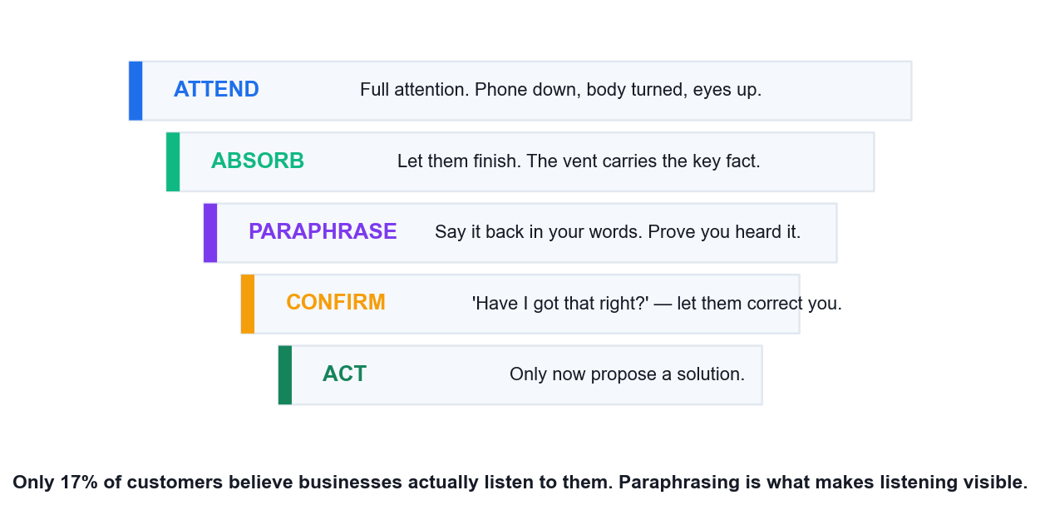
Active listening — paraphrasing is what makes listening visible to the customer.
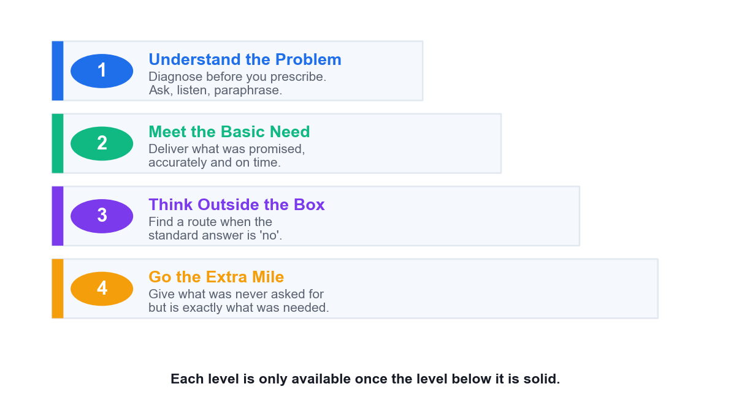
The four levels of addressing customer needs — a ladder, not a menu.
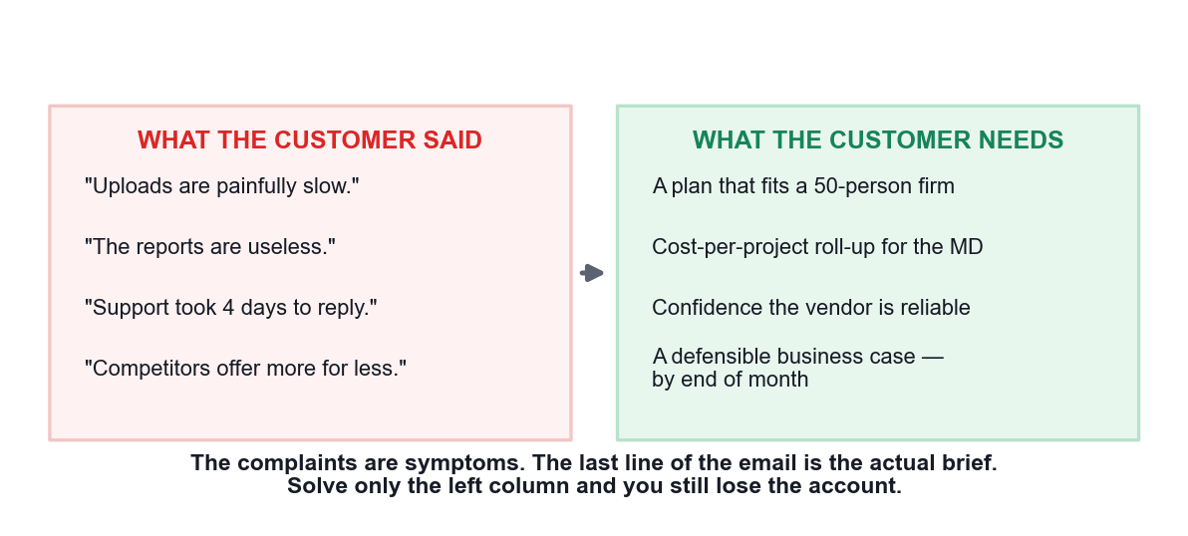
What the customer said versus what the customer needs.

Activity 3 — Diagnosing Customer Needs at a Growing SME — TechNova Account Review
Mapping: LO1 · Identify functional and emotional needs, and map them to the four levels of addressing needs.
Format: Case Study + Role Play · Duration: 25 minutes · Pairs. Role A = TechNova Account Manager, Role B = Daniel Lim. Observer optional.
Scenario
TechNova Solutions (Singapore) supplies a cloud project-management platform. Mr Daniel Lim is Operations Director at Horizon Builders Pte Ltd, a Woodlands-based construction firm and a customer for 6 years. Horizon has grown from 12 to 50 employees. Daniel emails: 'Uploads are painfully slow, the reports are useless for what we need, and it took your support team 4 days to answer my last ticket. Competitors are offering us more for less. I need to justify this renewal to my MD by end of month.'
What the account record shows: Horizon is on Team Pro (a 15-seat plan) with 50 users sharing logins. Upload slowness correlates with 200MB+ site photo batches — the plan caps concurrent uploads. The reporting Daniel wants (cost-per-project roll-up) exists in the Enterprise tier. The 4-day ticket was logged during the Chinese New Year holiday period. Daniel has never had a formal account review in 6 years.
What you will produce
A needs analysis separating stated complaints from root needs, mapped to the four levels of addressing needs. (Materials: Needs analysis worksheet · Four-levels template.)
Discussion questions
1. Separate what Daniel SAID from what Daniel NEEDS. Write two columns. They are not the same list.
2. Identify Daniel's FUNCTIONAL needs and his EMOTIONAL needs. Which one is driving the email's tone?
3. 'I need to justify this renewal to my MD by end of month.' What does this sentence tell you that the complaints do not?
4. Map your findings to the four levels: understand the problem / meet basic needs / think outside the box / go the extra mile. What sits at each level?
5. Horizon has 50 users on a 15-seat plan. This is a contract breach AND the cause of the slowness. How do you raise it without turning a save into a fight?
6. Six years, no account review. What does that reveal about TechNova's own service process — and what should change?
Step-by-step
1. Read the case individually. Underline every sentence where Daniel states a problem, and circle every sentence that tells you about his SITUATION rather than his complaint.
2. Draw two columns on your worksheet: WHAT HE SAID and WHAT HE NEEDS. Fill the left column first — it is quick, it is just his words. The right column takes longer because it requires inference.
3. Under WHAT HE NEEDS, tag each item F (functional) or E (emotional). If you have no E items, you have not finished — re-read the last sentence of his email.
4. On the four-levels template, place each need at the correct level. Level 1 (understand the problem) must be filled before you write anything at Level 2 — resist jumping to solutions.
5. Prepare five OPEN questions for the discovery call. Open questions start with what, how, tell me, walk me through. If a question can be answered yes/no, rewrite it.
6. Assign roles: A = Account Manager, B = Daniel Lim. B, you are frustrated but not abusive — you want to stay if given a reason.
7. Run a 6-minute discovery call. A opens by acknowledging the 6-year relationship, then asks the open questions and PARAPHRASES each answer back before moving to the next.
8. A must NOT propose an upgrade in the first 4 minutes. Diagnose before you prescribe — a plan upsell offered too early reads as a sales pitch and confirms Daniel's suspicion.
9. In the last 2 minutes, A summarises the needs back to Daniel and proposes one action at each of the four levels, ending with the extra-mile offer to build the MD's report.
10. Debrief: B rates whether A understood the real brief (the MD deadline) or only fixed the three complaints.
Debrief — what a strong answer looks like
- Said vs needed: he SAYS slow uploads, useless reports, slow support. He NEEDS a defensible business case for his MD by month end. Solve only the first three and you still lose the account.
- The emotional need is dominant: Daniel is exposed in front of his MD. The functional fixes are the evidence he needs to not look foolish for having stayed 6 years.
- The last sentence is the actual brief. Everything before it is symptoms. Learners who spot this are doing genuine needs identification rather than complaint triage.
- Four levels — understand: the plan no longer fits a 50-person firm. Basic: fix the upload cap and the ticket SLA. Outside the box: the seat overage is leverage for a migration, not a penalty. Extra mile: build the cost-per-project report FOR his MD deck.
- The 15-seat breach must be raised as a discovery, not an accusation: 'your growth has outrun the plan we sold you six years ago — that's on us for not reviewing it.'
- The real service failure is TechNova's: no account review in 6 years means nobody was listening until the customer shouted. The process fix is a scheduled review cadence — this is a Topic 7 closed-loop point arriving early.
Check your work
Your needs analysis has at least one emotional need identified, all four levels populated, and your role-play partner confirms you surfaced the MD deadline as the real brief.
Note: A printable one-page brief for this activity is in activities/activity-03/.

Topic 4 — In-Person Customer Service
Walk-ins and at-your-desk requests · body language · advantages and limits of face-to-face
Learning unit: LU1 · 50 min
Key concepts
- Face-to-face is highest bandwidth — Tone, posture, expression and timing all carry meaning that text channels strip away.
- Immediate feedback loop — Misunderstandings surface and are corrected within seconds — the strongest advantage over email or chat.
- Body language you control — Open posture, ~70% eye contact, a slight forward lean and subtle mirroring build rapport without a word.
- Signals that cost you trust — Crossed arms, glancing at a phone, turning away or a fixed forced smile all read as disengagement.
- Acknowledge within seconds — Greet a walk-in within about 3 seconds even when occupied; being seen matters before being served.
- The limits of in-person — No automatic record, queueing pressure and scheduling conflicts — document afterwards or it never happened.

Activity 4 — The Walk-In Interruption — Retail Service Counter, Bugis
Mapping: LO1 · Handle in-person and at-your-desk requests using body language and acknowledgement.
Format: Role Play · Duration: 15 minutes · Groups of 4. Role A = Service Officer, B = SIM customer, C = Ms Chen, D = observer/phone caller.
Scenario
A telco retail store at Bugis Junction, Saturday 2pm. You are at the service counter finishing a SIM registration for a customer who is standing beside you waiting for the confirmation SMS. The store phone rings. At the same moment, Ms Chen walks up to your counter holding a phone with a cracked screen and says 'Excuse me, I just need a quick answer' — she has been in the store for 20 minutes looking for someone. Two more customers are visibly waiting behind her.
You cannot serve three people at once. Everything you do in the next 15 seconds is visible to all of them.
What you will produce
A demonstrated acknowledgement sequence handling three competing demands without losing any of them. (Materials: Observer checklist · Timer.)
Discussion questions
1. In the first 15 seconds, what do you do — and in what order? Be specific about words, eyes and hands.
2. Ms Chen says 'I just need a quick answer'. Is it ever actually quick? What is the risk of treating it as quick?
3. How do you acknowledge Ms Chen without abandoning the customer already at your counter?
4. The phone is ringing and no one else can take it. What do you do, and what does the customer in front of you see you do?
5. What body language keeps all three parties feeling attended to while you can only serve one?
6. What is the 'park and return' method, and where exactly would you use it here?
Step-by-step
1. Set up the physical space: a counter, A behind it, B standing at the counter, C approaching from the side, D at a distance with a phone.
2. Brief each role privately. C (Ms Chen) has already waited 20 minutes and believes her question is 30 seconds long. She is polite but firm.
3. Run ONLY the first 15 seconds. Freeze on the trainer's call. Observers describe exactly what A did with eyes, hands, torso and words — in that order.
4. Discuss the freeze-frame as a group for 2 minutes. Most first attempts either ignore Ms Chen entirely or abandon the SIM customer. Name which one happened.
5. Reset and run the full scenario for 6 minutes with the phone ringing at the 20-second mark.
6. A applies the sequence: acknowledge C within 3 seconds without leaving B; handle the phone with a callback offer; complete B's registration; note the park point; then turn fully to C.
7. When A turns to C, A must NOT ask her to repeat why she is there — A should open with 'you mentioned a cracked screen' to prove she was heard the first time.
8. Observer (D) scores the checklist and reports: acknowledgement time in seconds, whether any customer was made to repeat themselves, and whether A's torso ever fully turned away from the active customer.
9. Rotate roles so at least two learners play the Service Officer.
Debrief — what a strong answer looks like
- Order matters: eye contact + a raised hand + 'I'll be right with you, about two minutes' to Ms Chen takes 3 seconds and buys 2 minutes. Being SEEN precedes being served.
- 'Quick answer' is almost never quick — a cracked screen means warranty status, purchase date, insurance and a repair booking. Treating it as quick means starting something you cannot finish and now failing two customers.
- The customer in front of you keeps priority. State that openly to the room: it reassures the person you are serving AND tells the queue there is a fair rule.
- The phone: let it go to the queue or answer with 'may I take your number and call you back in five minutes?' Never leave a physical customer standing while you have a full phone conversation — the person present outranks the person calling.
- Body language: keep your torso oriented to the counter customer, turn only your head to Ms Chen, and use an open palm rather than a pointed finger. Turning your whole body away is the abandonment signal.
- Park and return: note where you were in the SIM registration before you turn away, so you resume without asking the first customer to repeat anything. Making a customer re-explain is the failure this method exists to prevent.
Check your work
You acknowledged the walk-in within 5 seconds, no customer was asked to repeat themselves, and the observer confirms you never fully turned away from the customer you were actively serving.
Note: A printable one-page brief for this activity is in activities/activity-04/.

Topic 5 — Customer Service Over the Phone
Telephone etiquette · voice as the whole channel · hold and transfer · call structure
Learning unit: LU1 · 50 min
Key concepts
- Voice carries everything — With no visual channel, tone, pace and warmth do all the work that body language does in person.
- Phone still dominates complex issues — When an issue needs back-and-forth clarification, customers still reach for the phone over text channels.
- Etiquette is measurable — Answer within three rings, smile while speaking, never interrupt, avoid jargon, always close with next steps.
- Hold is a permission, not an action — Ask before holding, explain why, give a time, thank them on return — otherwise it reads as being dumped.
- Paraphrase to prove you listened — 'So the order was due Monday and hasn't arrived' converts a vent into a defined, solvable problem.
- Scripts guide, they don't speak — Rigid scripts sound robotic. Use them as a spine and personalise the words to the caller in front of you.
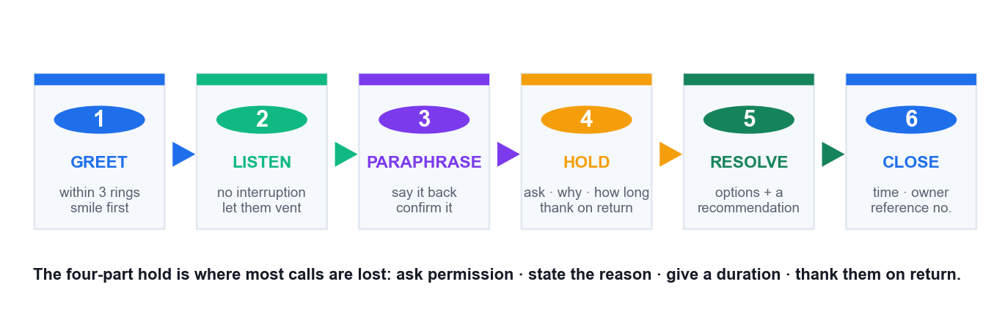
The professional call — six stages, with the four-part hold at stage 4.

Activity 5 — The Angry Delivery Call — Logistics Hotline
Mapping: LO1 · Apply telephone etiquette, paraphrasing and hold technique with an angry caller.
Format: Role Play · Duration: 15 minutes · Pairs, seated back to back so there is no visual channel. A = Hotline Officer, B = Mr Faisal.
Scenario
You work the customer hotline for a Singapore last-mile logistics firm. Mr Faisal calls at 4:15pm. His package — a replacement CPAP machine part his father needs — was due Monday. It is now Thursday. Tracking has said 'out for delivery' for three days. He has called twice before; both times he was told 'it will be delivered today'. He opens the call at volume: 'I've been lied to twice. Don't tell me it's out for delivery. Where is my package?'
What you find while he is talking: the parcel was mis-sorted to the Jurong hub on Monday, scanned back out Wednesday, and is genuinely on a van today — but the van's route ends at 9pm and he is stop 61 of 68. You can request a priority re-route (needs hub supervisor approval, ~10 minutes) or offer next-morning guaranteed delivery before 10am.
What you will produce
A complete recorded-style call demonstrating the six-stage phone flow with a compliant hold. (Materials: Phone flow card · Observer checklist · Timer.)
Discussion questions
1. Mr Faisal opens by shouting. What are your first words, and how long do you let him talk before you speak?
2. He says 'I've been lied to twice.' Is that true? How do you respond to it without blaming a colleague or defending the company?
3. Write the exact sentence you would use to paraphrase his issue back to him.
4. You need 10 minutes to get supervisor approval. How do you place him on hold correctly — what four things must you say?
5. You have two options (priority re-route vs guaranteed next morning). Do you choose for him or offer both? Why?
6. Why does the CPAP detail change how you handle this call, and what would you have missed if you had interrupted him?
Step-by-step
1. Seat the pair back to back. This is not a gimmick — removing the visual channel is the entire point of practising phone service.
2. B (Mr Faisal) reads the customer brief only. B must open at high volume and must mention the CPAP machine and his father within the first 40 seconds, unprompted.
3. A answers within three rings with the full greeting: company, own name, offer of help. A smiles before speaking — it changes the voice even though nobody can see it.
4. A does NOT speak again until B has finished venting. A may use minimal acknowledgement sounds ('mm-hm', 'I see') but no sentences and no interruptions.
5. A acknowledges the experience first, then paraphrases the whole issue back including the father and the CPAP part. A waits for B to confirm the paraphrase is right before moving on.
6. A places B on hold correctly: 'May I put you on hold for about three minutes while I get my hub supervisor to authorise a priority re-route? ... Thank you for waiting.' All four elements, in order.
7. A returns and presents BOTH options with a recommendation and a reason tied to the father's need. A lets B choose.
8. A closes with concrete next steps: what will happen, by when, who will call, and a reference number. Vague closes ('we'll look into it') fail this step.
9. A commits to ONE proactive follow-up — a call tomorrow confirming delivery, made whether or not it succeeded.
10. Observer scores: interruption count (target 0), paraphrase accuracy, all four hold elements present, and whether the close contained a time and an owner.
Debrief — what a strong answer looks like
- Let him finish. The first 30–45 seconds are venting and contain the CPAP detail — the single most important fact in the call. An officer who interrupts to defend the tracking system never learns why this parcel matters.
- 'I've been lied to twice' — do not defend and do not blame. 'You were given a delivery promise twice and it did not happen. That's on us.' Acknowledging the customer's EXPERIENCE is not admitting to a lie.
- Good paraphrase: 'So your father's CPAP part was promised Monday, you've called twice, been told it's out for delivery each time, and four days on you still have nothing.' Naming the father is what proves you listened.
- Correct hold has four parts: ask permission, state the reason, give a realistic duration, thank them on return. Missing any one of these makes the hold feel like being dumped.
- Offer both options with a recommendation. The CPAP context makes guaranteed 10am delivery likely better than stop 61 at 9pm — but it is his father and his call. Choosing FOR the customer removes the one piece of control he still has.
- This call is a Topic 7 case in disguise: the mis-sort is the fault, but the SERVICE failure is two false promises. Note it for the feedback loop — the fix is not promising a date the system cannot see.
Check your work
You did not interrupt during the opening vent, your paraphrase included the father/CPAP detail, your hold had all four elements, and your close named a specific time and owner.
Note: A printable one-page brief for this activity is in activities/activity-05/.

Topic 6 — Customer Service via Email and Chat
Netiquette · email structure · written tone · choosing between email and live chat
Learning unit: LU1 · 45 min
Key concepts
- Writing is a service skill — 'You have to log out first' and 'Logging out should fix that quickly!' carry identical information and opposite tone.
- Email creates the record — The written trail is the channel's real advantage: the customer can re-read it and you can prove what was agreed.
- Netiquette rules are not optional — No ALL CAPS, no unexplained jargon, a clear action-oriented subject line and a real signature block.
- A five-part email structure — Personalised greeting → acknowledge the issue → give the solution → state next steps → professional sign-off.
- Email vs live chat — Email suits complex, documented, attachment-bearing issues; chat suits short, real-time, single-question issues.
- Proofread before you send — Grammar and spelling errors read as carelessness and quietly transfer to how the customer rates your competence.
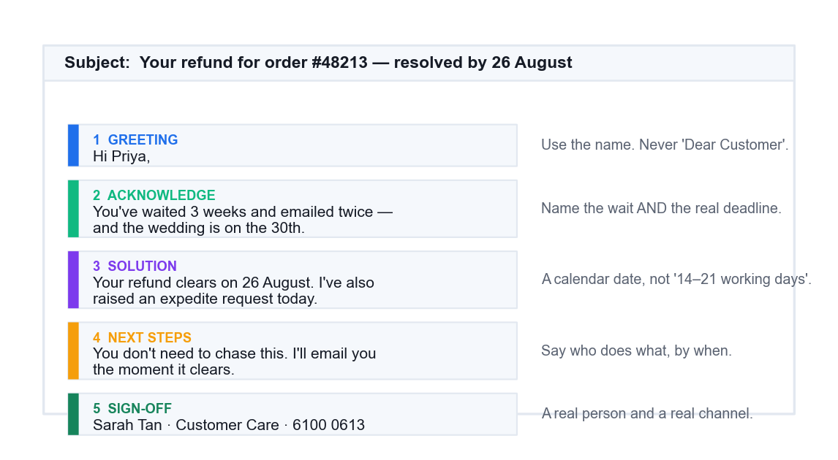
The five-part service email.
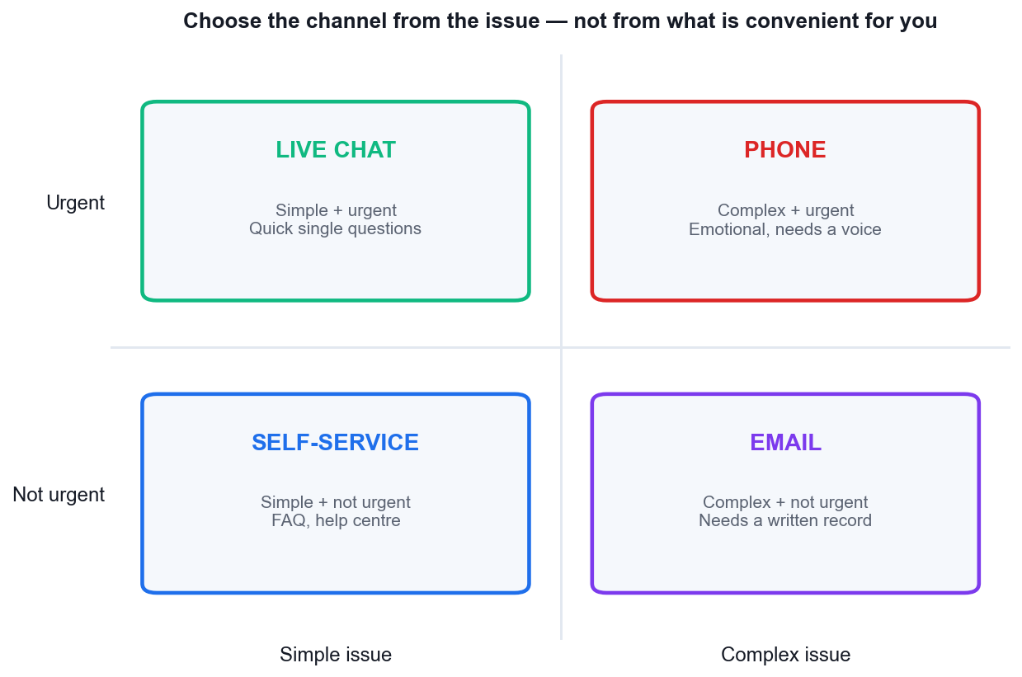
Choosing the channel from the issue: urgency against complexity.

Activity 6 — Rewriting the Refund Email — E-Commerce Support Inbox
Mapping: LO1 · Apply netiquette and the five-part email structure; choose email vs chat correctly.
Format: Case Study + Practical Writing · Duration: 15 minutes · Individually, then compare in pairs.
Scenario
A Singapore online fashion retailer. Ms Priya ordered a dress for her sister's wedding on 2 August, paid S$189, and received the wrong size. She returned it on 8 August using the prepaid label. It is now 22 August, no refund has appeared, and the wedding is on 30 August. She has emailed twice.
The agent's reply, sent as-is:
Subject: RE: RE: FW: order
Dear Customer,
As per our T&C section 7.3 refunds are processed within 14-21 WORKING DAYS from receipt at our warehouse NOT from when you posted it. Your return was received 14/8. Therefore your refund is NOT late and there is nothing further we can do at this time. Please do not email again as it does not speed up the process.
Regards,
Support Team
Every fact in that email is correct. It is still a service failure.
What you will produce
A rewritten email following the five-part structure, plus a channel-choice justification. (Materials: Email structure template · Netiquette checklist.)
Discussion questions
1. List every netiquette failure in the agent's email. There are at least seven.
2. Every fact in the email is accurate. Explain how an email can be 100% correct and still be a service failure.
3. What is the customer's REAL deadline, and does the agent's reply acknowledge it at all?
4. Rewrite the email using the five-part structure: greeting → acknowledge → solution → next steps → sign-off.
5. 'Please do not email again.' What does this sentence do to the relationship, and what should replace it?
6. Should this have been email, live chat or a phone call? Justify your choice against the channel-selection rule.
Step-by-step
1. Read the agent's email once at normal speed, then a second time slowly with the netiquette checklist beside you.
2. Mark every failure directly on the email text. Aim for at least seven. Compare with your partner — most people miss the unsigned 'Support Team' and the dead subject line.
3. In one sentence, write what the agent got RIGHT. There is something: the facts and the policy citation are accurate. This matters, because it shows accuracy is not the same as service.
4. Write down the customer's real deadline (30 August, the wedding) and check whether it appears anywhere in the agent's reply. It does not. That absence is the core failure.
5. Now rewrite. Part 1 — greeting: use her name. Part 2 — acknowledge: name the wait, the two prior emails and the wedding, and apologise for the experience without disputing the policy.
6. Part 3 — the solution: state the actual refund date as a calendar date, not 'within 14–21 working days'. Add one concrete action you will take (raise an expedite request, or ship the correct size now against the pending refund).
7. Part 4 — next steps: say exactly what happens next, when, and who does it. Make it clear she does not need to chase.
8. Part 5 — sign-off: your real name, your role, and a direct contact channel. Never 'Support Team'.
9. Fix the subject line last: make it specific and action-oriented, e.g. 'Your refund for order #48213 — resolution by 26 August'.
10. Swap with your partner. Score their rewrite against the netiquette checklist and confirm all five parts are present and the wedding date is acknowledged.
11. Finally, write two lines justifying the channel you would have used, referencing complexity, urgency, emotion and the need for a record.
Debrief — what a strong answer looks like
- Netiquette failures to find: 'RE: RE: FW: order' subject line, 'Dear Customer' not her name, ALL CAPS as shouting, policy-section jargon (T&C 7.3), no apology or acknowledgement, an instruction not to make contact, an unsigned 'Support Team' with no individual name, and no next step the customer can act on.
- Correct-but-failing is the key lesson: the agent answered the question the customer TYPED and ignored the question she MEANT — 'will I have this sorted before the wedding on the 30th?'
- The wedding date is the real deadline and the email never mentions it. This is the same 'said vs needed' distinction from Activity 3, in writing.
- A good rewrite names Priya, acknowledges two prior emails and the wedding, states the refund date with a specific day, offers something concrete (expedite request, or a replacement in the right size shipped now), and gives a named person and direct contact.
- 'Please do not email again' tells the customer her only channel is closed. Replace with proactive ownership: 'You don't need to chase this — I'll email you the moment it clears, and here's my direct line.'
- Channel: email is right for the RECORD (money, dates, policy), but this case needed a phone call first because it is time-critical and emotional. Best practice is call, then confirm in writing — using both channels for what each does well.
Check your work
Your rewrite has all five parts, names the customer, acknowledges the 30 August wedding, gives a calendar date rather than a working-day range, and is signed by a named person.
Note: A printable one-page brief for this activity is in activities/activity-06/.

Topic 7 — Generating Return Business from Feedback
Feedback channels · closing the loop · complaint handling · retention economics
Learning unit: LU2 · 65 min
Key concepts
- Retention beats acquisition — Keeping a customer costs far less than winning a new one; a 5% retention lift can move profit 25–95%.
- Feedback channels are a portfolio — Surveys, reviews, interviews, social listening, support tickets and staff reports — each has a bias, so triangulate.
- CSAT, NPS and CES measure differently — CSAT rates a moment, NPS rates the relationship, CES rates the effort the customer had to spend.
- Most unhappy customers say nothing — Roughly 56% leave silently. The absence of complaints is not evidence of satisfaction.
- Closing the loop is the point — Collect → analyse → act → tell the customer what changed. Feedback with no visible action trains people to stop giving it.
- Recovery can beat no failure at all — A well-recovered failure often leaves the customer more loyal than a customer who never had a problem.
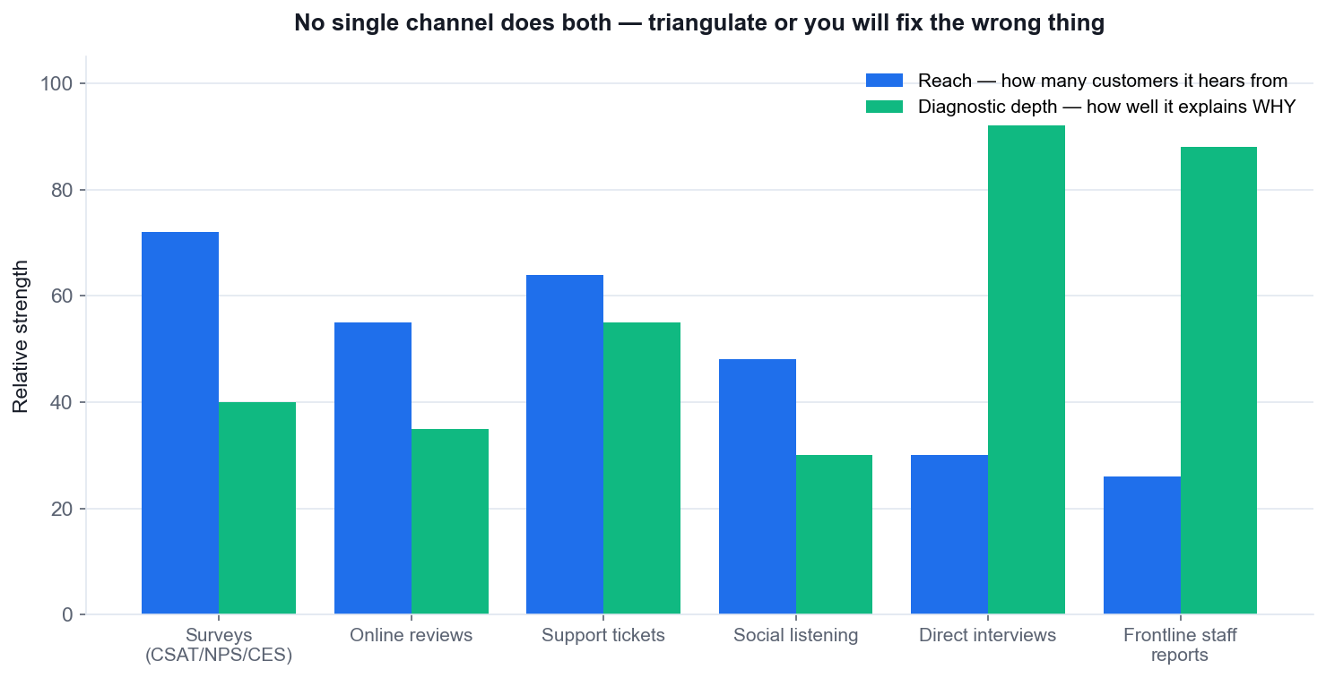
Feedback channels — reach versus diagnostic depth. No channel does both.
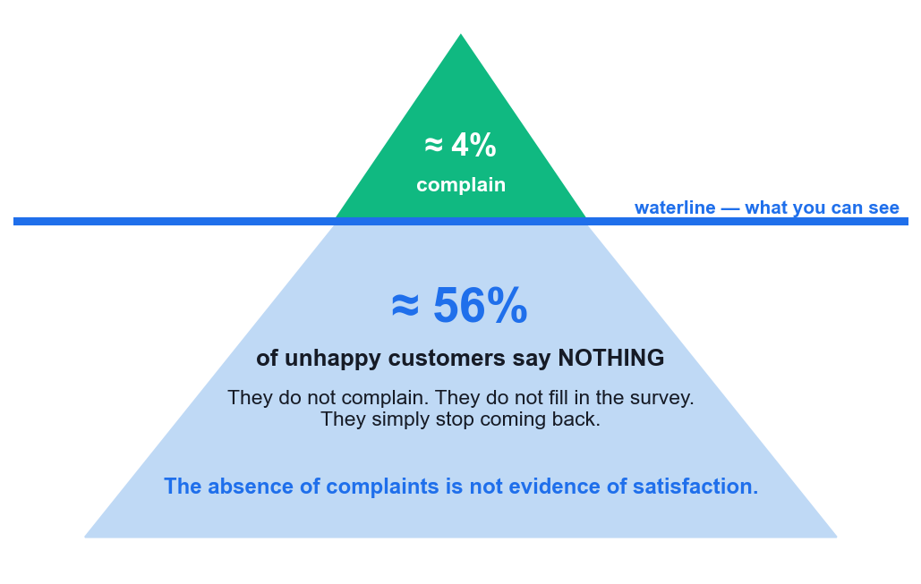
Most unhappy customers never complain — silence is not satisfaction.
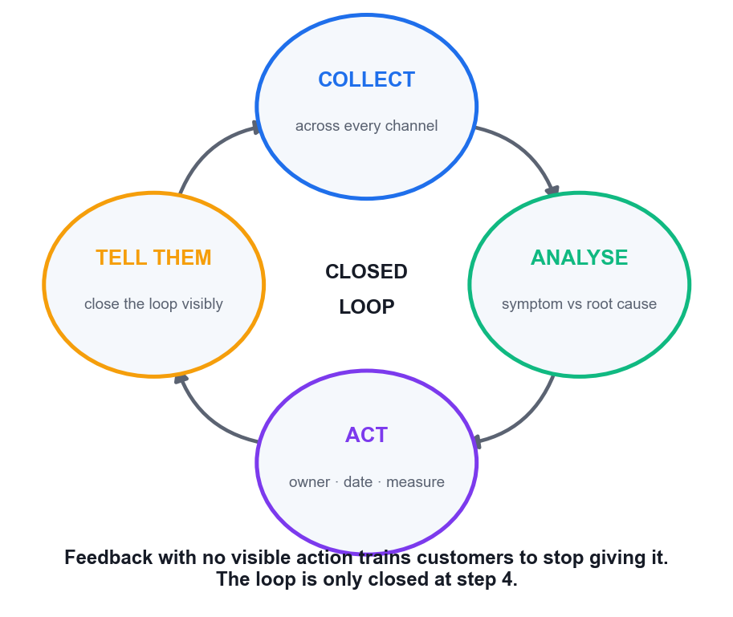
Closing the loop — only step 4 is visible to the customer.

Activity 7 — Closing the Loop — F&B Chain Losing Repeat Customers
Mapping: LO2 · Analyse multi-channel feedback, find root causes, and build a closed-loop improvement plan.
Format: Case Study + Group Presentation · Duration: 25 minutes · Groups of 4–5. Each group presents a 3-minute plan to the class acting as management.
Scenario
Kopi & Co is a Singapore café chain with 9 outlets. Repeat-customer rate has fallen 15% this quarter. Management wants a recovery plan. Here is the feedback that exists:
GOOGLE REVIEWS (rating fell 4.4 → 3.8): 'Waited 25 min for a flat white at Raffles Place, staff seemed overwhelmed.' · 'Ordered on the app, got the wrong drink twice.' · 'Nobody acknowledged me at the counter for 5 minutes.' · 'Food is still great, service has really slipped.'
POST-VISIT SURVEY (CSAT 62%, down from 81%): lowest-scoring item is 'speed of service' (48%); highest is 'product quality' (91%). Only 4% of visitors complete the survey.
SUPPORT TICKETS: app order errors up 3x since the June app update. 70% of tickets are wrong-item.
STAFF FEEDBACK (from a shift-leader WhatsApp group, never formally collected): 'The new app sends orders to the bar without the modifier field.' · 'We lost 2 baristas at Raffles Place in May, still not replaced.' · 'Nobody from HQ has asked us anything.'
Nothing has been fed back to any customer who left a review or completed a survey.
What you will produce
A closed-loop improvement plan: root causes, 3+ strategies, owners, timeline and success measures. (Materials: Feedback analysis grid · Closed-loop plan template.)
Discussion questions
1. Sort every piece of feedback by CHANNEL. What is each channel good at capturing, and what does each one miss?
2. Only 4% complete the survey and CSAT is 62%. What is wrong with concluding '62% of our customers are satisfied'?
3. Separate SYMPTOMS from ROOT CAUSES. The 25-minute wait is a symptom — what is causing it?
4. The staff feedback identifies the app modifier bug that support tickets only show as 'wrong item'. What does that tell you about operational feedback channels?
5. Not one customer who left feedback has heard anything back. What does that cost, beyond this quarter?
6. Build the plan: at least 3 strategies, each with an owner, a timeline and a success measure. What will you measure, and when will you know it worked?
Step-by-step
1. Form groups of 4–5. On a flip chart, draw a four-column grid: REVIEWS · SURVEY · TICKETS · STAFF.
2. Place every piece of feedback from the case into its column. Then, under each column, write one line on what that channel is GOOD at seeing and one line on what it is BLIND to.
3. Discuss the 4% response rate. Write down explicitly why 62% CSAT cannot be read as '62% of customers are satisfied' — name the non-response bias and the silent-majority effect.
4. Draw a second area: SYMPTOMS on the left, ROOT CAUSES on the right. Move each item across only when you can state the mechanism. '25-minute wait' moves to the right only as 'Raffles Place is 2 baristas short'.
5. You should end with exactly three root causes. If you have more than five, you are still listing symptoms; if you have one, you have over-consolidated.
6. For each root cause, write one strategy. A strategy must name WHO does WHAT by WHEN. Reject any strategy that is a slogan.
7. Add a fourth strategy that fixes the MISSING closed loop itself — how will customers who gave feedback be told what changed? This is the strategy most groups forget.
8. For every strategy, define a success measure with a number and a review date. 'Wrong-item tickets below 10/week by 30 Sept' is a measure; 'better service' is not.
9. Add a fifth element: how will you collect STAFF feedback formally from now on, so the next modifier bug does not sit in WhatsApp for three months?
10. Prepare a 3-minute presentation: the three root causes, your strategies with owners and dates, your measures, and your closed-loop mechanism. Nominate one presenter.
11. Present to the class. The class acts as management and must ask one challenging question per group.
Debrief — what a strong answer looks like
- Channel biases: reviews capture the extremes (delighted and furious) and skew negative; surveys capture the compliant middle; tickets capture only what customers bothered to report; staff feedback captures CAUSES the other three only show as symptoms.
- 4% response rate means severe non-response bias — and roughly 56% of unhappy customers never complain at all. 62% CSAT is the score of the 4% willing to answer, not of the customer base.
- Root causes are: (1) the June app update dropped the modifier field, (2) Raffles Place is 2 baristas short since May, (3) there is no closed loop so nothing gets fixed. The 25-minute wait and the wrong drinks are downstream of these.
- The staff channel had the highest-value diagnostic information in the whole case — and it was sitting in an informal WhatsApp group because no formal operational feedback channel exists. This is exactly the operational feedback gap.
- Silence costs the future: customers who give feedback and see nothing change stop giving feedback, and the early-warning system goes dark. The 15% drop is what you can see; the lost channel is what you cannot.
- A good plan is specific: 'Ops Manager fixes the modifier field by 5 Sept, measured by wrong-item tickets falling below 10/week' beats 'improve the app'. Push every group to name an owner, a date and a number.
Check your work
Your plan names 3 root causes (not symptoms), has an owner and date for every strategy, includes a numeric success measure, and contains an explicit mechanism for telling customers what changed.
Note: A printable one-page brief for this activity is in activities/activity-07/.

Topic 8 — Recovering Difficult Customers
De-escalation · HEARD and LAST · common ground · limits · managing your own emotions
Learning unit: LU2 · 60 min
Key concepts
- Recovery restores the relationship — The goal is not only to fix the fault but to rebuild the trust the fault destroyed.
- HEARD framework — Hear · Empathize · Apologize · Resolve · Diagnose — let them finish, then act, then prevent the recurrence.
- LAST framework — Listen · Apologize · Solve · Thank — thank them for surfacing a problem you would otherwise not have seen.
- Perceived justice has three parts — Customers judge the outcome, the process and how they were treated. Fix the fault and still fail on the last two.
- Establish common ground — 'We both want this resolved fairly today' converts an adversarial exchange into a shared problem.
- Manage yourself first — Detach from the personal, control breathing and pace, keep language neutral. Composure is the de-escalation tool.
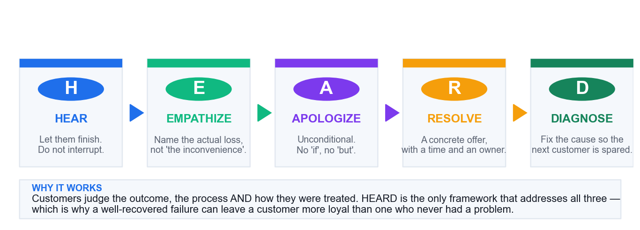
HEARD — the service-recovery sequence.

Activity 8 — Service Recovery Under Pressure — The Wedding Catering Failure
Mapping: LO2 · Apply HEARD/LAST de-escalation, establish common ground and set limits professionally.
Format: Role Play + Case Study · Duration: 15 minutes · Pairs or trios. A = Duty Manager, B = Mr Wong, C = observer scoring against HEARD.
Scenario
You are the Duty Manager for a Singapore catering company. Yesterday you catered a 200-guest wedding at a hotel ballroom in Novena. Three failures occurred: the vegetarian main course (40 portions, pre-ordered and confirmed in writing) was never loaded onto the truck; service started 35 minutes late; and the wedding cake was delivered with visible damage to one side.
The bride's father, Mr Wong, paid S$18,400. He is in your office now. He has photographs. He has already posted a one-star review naming your company. He is demanding a full refund and says he will 'make sure nobody in Singapore uses you again'.
What you know internally: the vegetarian order WAS in the system — the kitchen printed the run sheet before the final amendment was saved, a known gap flagged twice by kitchen staff and never fixed. Your authority extends to a 40% refund; anything beyond that needs the Director, who is contactable.
You cannot un-ruin the wedding. That is the constraint you are working inside.
What you will produce
A full recovery conversation applying HEARD, plus a written root-cause fix for the run-sheet gap. (Materials: HEARD framework card · LAST framework card · Observer scoring sheet.)
Discussion questions
1. Apply HEARD to this case. Write what you would actually SAY at each of the five stages.
2. You cannot undo the wedding. What are you actually recovering, and is recovery even possible here?
3. Mr Wong demands a full refund; you can authorise 40%. How do you set that limit without sounding like you are haggling over his daughter's wedding?
4. The kitchen flagged the run-sheet gap twice and nothing was done. Do you tell Mr Wong that? Argue both sides.
5. Perceived justice has three parts — outcome, process and treatment. Which of the three can you still influence here?
6. Design the process fix. What exactly changes so this cannot happen to the next customer?
Step-by-step
1. Brief the roles separately. B (Mr Wong) must open by placing the photographs down and must NOT accept the first offer. B is devastated and angry, but not abusive — this is recovery practice, not escalation practice.
2. A prepares for 2 minutes using the HEARD card. Write one opening sentence for each of the five stages before starting. Do not improvise the apology.
3. Begin. A must let B speak completely — including the review threat — before saying anything beyond acknowledgement sounds. Observer times this; interrupting inside the first 90 seconds is the most common failure.
4. A empathises by naming the specific loss: the vegetarian guests who had nothing to eat, the 35-minute delay in front of 200 people, the cake in the photographs. Generic phrases like 'I understand your frustration' score zero here.
5. A apologises unconditionally. No 'if you were disappointed', no 'but the kitchen', no policy citation. One clean sentence taking ownership.
6. A resolves: state the 40% refund as immediate and already authorised, and state that you are taking the balance to the Director today. Give a specific callback time.
7. A establishes common ground before setting the limit: 'we both want this made right' — then set the limit calmly and once. Do not repeat or defend it if B pushes; restate the escalation path instead.
8. A diagnoses aloud: explain that a process gap let the amended order miss the run sheet, and that it is being closed. Decide as a pair how much detail to disclose — you will defend that choice in the debrief.
9. Observer scores each HEARD stage present/absent, times the first interruption, and notes whether the apology contained any conditional word ('if', 'but', 'however').
10. After the role play, both partners write the process fix together: the specific system or procedural change, its owner, and how Mr Wong will be told about it.
11. Swap roles and rerun with a different disclosure decision, so both learners experience receiving the recovery.
Debrief — what a strong answer looks like
- HEARD in practice — Hear: let him show the photographs and finish, however long it takes. Empathize: 'this was your daughter's wedding and we damaged it' — name the actual loss, not 'the inconvenience'. Apologize: unconditional, no 'if' and no 'but'. Resolve: a concrete offer, now. Diagnose: the run-sheet gap, named to him as a real fix.
- What you are recovering is not the wedding — it is Mr Wong's standing. He chose this vendor and it failed in front of 200 guests including his extended family. The dignity loss is larger than the money.
- Setting the limit: never haggle. State the 40% as immediate and unconditional, then say you are taking the rest to the Director TODAY with your own recommendation, and give a time you will call back. Being on his side of the table is the move.
- Disclosing the known gap: strong arguments both ways. Disclosing shows honesty and makes the fix credible; it also hands him evidence of negligence. Most groups land on acknowledging a 'known process gap we failed to close' without the detail that it was flagged twice — accurate, honest, not self-incriminating. There is no single right answer here and the discussion is the point.
- Outcome is largely fixed (money is all that is left). But PROCESS and TREATMENT are entirely still in your hands — and research on perceived justice says those two often matter more than the refund amount.
- The fix: lock the run sheet against the live order record at print time, or block printing until amendments are closed. Then close the loop — tell Mr Wong what changed, in writing, a week later. That last step is what converts a detractor.
Check your work
All five HEARD stages were delivered, your apology contained no conditional words, you set the 40% limit once without haggling, and you produced a written process fix with an owner.
Note: A printable one-page brief for this activity is in activities/activity-08/.

Topic 9 — Understanding When to Escalate
Functional vs hierarchical escalation · triggers · the three-strike rule · documentation · POHA
Learning unit: LU2 · 50 min
Key concepts
- Escalation is a decision, not a failure — Handing over to the right authority or expertise faster is better service than struggling on alone.
- Functional vs hierarchical — Functional escalation goes sideways to expertise; hierarchical escalation goes upward to authority.
- Angry is not the same as abusive — An angry customer attacks the problem. An abusive customer attacks you — that line is the escalation trigger.
- Know the trigger behaviours — Vulgarity, personal insults, discriminatory remarks, legal threats and any threat of physical harm.
- The three-strike rule — Two clear, calm warnings that the behaviour must stop, then escalate or end the interaction.
- Singapore protects service staff — POHA 2014 criminalises workplace harassment; incidents can go to TAFEP or the police. Document everything.
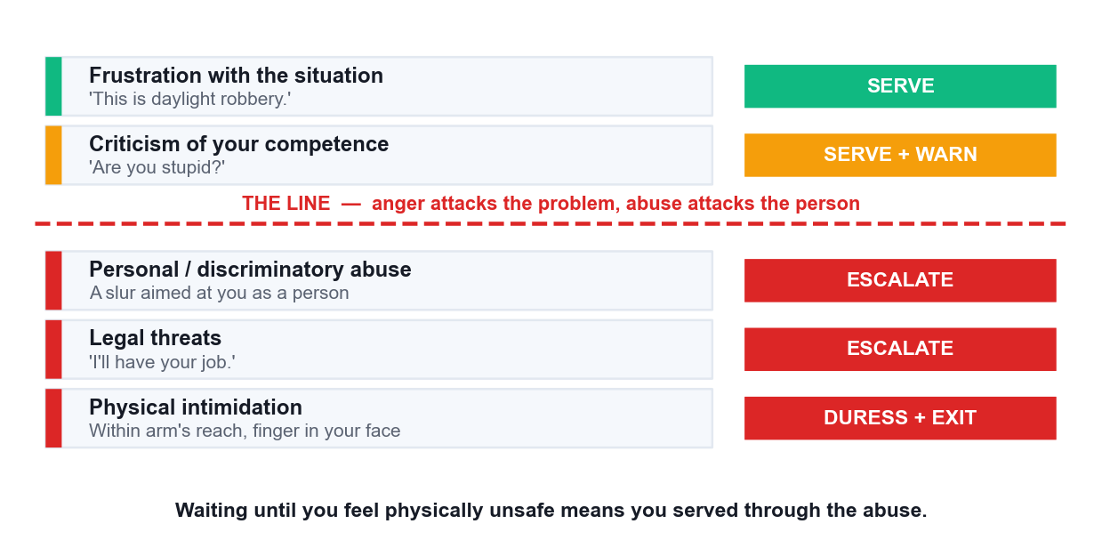
Where the line is: anger attacks the problem, abuse attacks the person.

Activity 9 — Drawing the Line — Escalation and Abuse at a Service Counter
Mapping: LO2 · Distinguish anger from abuse, apply the three-strike rule, escalate correctly and document.
Format: Role Play + Decision Exercise · Duration: 15 minutes · Trios. A = Service Officer, B = Mr Teo (trainer may play this role), C = supervisor/observer.
Scenario
You are a service officer at a telco flagship store on Orchard Road. Mr Douglas Teo is disputing a S$680 roaming bill from a trip to Australia. He says he was never told data roaming was not included. The account notes show a confirmation SMS was sent and opened. The charge is valid under the contract.
The interaction escalates over 8 minutes:
0:00 He raises his voice: 'This is daylight robbery.'
2:00 'Are you stupid? Can you even read English?'
4:00 He calls you an offensive name related to your race.
5:30 'I'm going to CASE, and I'll have your job. What's your full name and NRIC?'
7:00 He steps behind the counter line, moves within arm's reach, and points a finger in your face.
Other customers are present. Your supervisor is on the shop floor. There is a duress button under the counter and CCTV covering the area.
What you will produce
A completed escalation decision log and an incident report for the abusive interaction. (Materials: Escalation trigger checklist · Incident report template · Three-strike rule card.)
Discussion questions
1. Go through the timeline. At each timestamp, classify the behaviour as ANGRY or ABUSIVE. Where exactly is the line?
2. Which timestamp is the point of no return — where continuing to serve is the wrong decision? Justify it.
3. Apply the three-strike rule to this timeline. What are your two warnings, word for word?
4. Is this functional escalation or hierarchical escalation? Would your answer change if the dispute were technical rather than behavioural?
5. He demands your full name and NRIC. What are you obliged to give, and what are you not?
6. At 7:00 he is within arm's reach and pointing at your face. What do you do in the next 5 seconds, in order?
7. What must go into the incident report, and why does the exact wording he used need to be recorded verbatim?
Step-by-step
1. Individually, take the escalation trigger checklist and classify each of the five timestamps as ANGRY or ABUSIVE. Do this before any discussion so you commit to a personal threshold first.
2. Compare in your trio. Where you disagree, argue it out. Most disagreement clusters around 2:00 ('are you stupid') — insulting your competence versus insulting you as a person.
3. As a group, mark the single timestamp you consider the point of no return. Write one sentence justifying it. Be prepared to defend it to the class.
4. Write your two warnings word for word on the three-strike card. Read them aloud to each other — if either sounds sarcastic or raised when spoken, rewrite it.
5. Run the role play from 0:00. B escalates on the timeline; A responds. The trainer may play B for this activity because the racial slur is difficult to deliver as a peer.
6. A issues warning one at the appropriate point, and warning two at 4:00 while simultaneously signalling the supervisor. A does NOT continue trying to resolve the bill after 4:00.
7. A hands over to C (supervisor) with a clean, brief handover in front of the customer: the issue, what has been offered, and the behaviour that triggered the escalation. A then physically withdraws.
8. Run the 7:00 physical-proximity moment separately as a freeze-frame exercise. A demonstrates the five-second sequence: step back, hands visible, verbal boundary, signal, duress button.
9. A completes the incident report template: date, time, location, verbatim words, witnesses, CCTV reference, actions taken, notifications made. Verbatim means verbatim — do not sanitise it.
10. As a group, add the POHA and TAFEP references to the report: harassment at work is a criminal matter, reportable to TAFEP or the police, and the employer has a legal duty to provide a safe workplace.
11. Close with the wellbeing step most teams skip: what does the officer need AFTER this interaction — a break, a debrief with the supervisor, and a follow-up the next day.
Debrief — what a strong answer looks like
- The line: 0:00 and 2:00 are anger directed at the situation and then at your competence — unpleasant but serviceable. 4:00 is the crossing point: a racial slur is abuse of the PERSON and is a criminal matter under POHA, not a service problem.
- Point of no return is 4:00, not 7:00. Most learners wait for the physical proximity. Waiting until you feel physically unsafe means you served through the abuse — the threshold is the slur, and it is not negotiable or 'part of the job'.
- Warnings must be calm, specific and behavioural: 'Mr Teo, I want to help you with this bill, but I cannot continue if you speak to me that way.' Second: 'If that continues I will need to hand this to my supervisor and end our conversation.' Never sarcastic, never raised.
- This is HIERARCHICAL escalation — it needs authority, not expertise. A technical roaming dispute would be FUNCTIONAL escalation to a billing specialist. Same customer, same bill, entirely different escalation path.
- You give your first name or staff ID — that is standard and reasonable. You never give your NRIC or personal details. Deflect: 'my name is X and my staff ID is Y, and my supervisor will give you the complaint reference.'
- At 7:00, in order: step back to restore distance, keep hands visible and open, do not turn your back, say clearly 'please step back behind the counter', signal or press for the supervisor, and press the duress button if he does not comply. Do not attempt to win the exchange.
- The report needs date, time, location, the exact words used verbatim, witnesses present, CCTV reference, actions taken and who was notified. Verbatim matters because POHA and any police report turn on what was actually said — paraphrase destroys the evidence.
Check your work
You identified 4:00 as the escalation threshold, delivered two calm behavioural warnings, handed over without continuing to serve, and produced an incident report containing the verbatim wording and a CCTV reference.
Note: A printable one-page brief for this activity is in activities/activity-09/.

Common Service Pitfalls to Avoid
- Jumping to a solution before diagnosing the need — always paraphrase and confirm first.
- Apologising conditionally ('if you were inconvenienced') instead of unconditionally.
- Recommending a vague improvement ('improve communication') with no owner, date or measure.
- Failing to name a feedback channel when asked how feedback would be collected.
- Continuing to serve after abuse, instead of warning and escalating.
- Ending the interaction without stating concrete next steps, a time and an owner.

Quick Reference — The Frameworks in This Course
- The service chain — Internal support → frontline delivery → customer experience → loyalty and revenue. A break anywhere upstream surfaces as a frontline failure.
- Four principles of good service — Personalised · Competent · Convenient · Proactive. All four must hold.
- Active listening — Attend → Absorb → Paraphrase → Confirm → Act. Paraphrasing is what makes listening visible.
- Four levels of addressing needs — 1 Understand the problem · 2 Meet the basic need · 3 Think outside the box · 4 Go the extra mile. You cannot skip a rung.
- Park and return — Note where you stopped so the customer never has to repeat themselves.
- The six-stage call — Greet → Listen → Paraphrase → Hold → Resolve → Close.
- The four-part hold — Ask permission · state the reason · give a duration · thank them on return.
- Five-part service email — Greeting → Acknowledge → Solution → Next steps → Sign-off.
- Channel selection — Match the channel to the issue: urgency on one axis, complexity on the other.
- CSAT / NPS / CES — CSAT rates a moment · NPS rates the relationship · CES rates the customer's effort.
- The closed loop — Collect → Analyse → Act → Tell them. Only step 4 is visible to the customer.
- HEARD — Hear · Empathize · Apologize · Resolve · Diagnose.
- LAST — Listen · Apologize · Solve · Thank.
- Perceived justice — Customers judge the outcome, the process AND how they were treated.
- Functional vs hierarchical escalation — Sideways for expertise; upward for authority.
- The three-strike rule — Two calm behavioural warnings, then escalate or end. Abuse skips the warnings.

Glossary
- Customer service — The whole of the support a customer receives before, during and after a purchase.
- External customer — An individual or business that buys your products or services.
- Internal customer — A colleague or department that depends on your work output.
- Service recovery — Resolving a service failure so as to restore the customer's trust, not merely fix the fault.
- Active listening — Attending fully, paraphrasing back and confirming before responding.
- Positive language — Framing a response around what IS possible rather than what is not.
- Netiquette — The conventions of polite, professional written communication online.
- CSAT — Customer Satisfaction score — how satisfied a customer was with a specific interaction.
- NPS — Net Promoter Score — how likely a customer is to recommend you.
- CES — Customer Effort Score — how much effort the customer had to spend to get resolution.
- Closing the loop — Telling the customer what changed as a result of the feedback they gave.
- Root cause — The underlying reason a problem occurs, as opposed to the symptom the customer reports.
- De-escalation — Reducing a customer's emotional intensity so the problem can be addressed.
- Escalation — Transferring an issue to someone with the required expertise or authority.
- POHA — Protection from Harassment Act 2014 — Singapore legislation criminalising harassment, including abuse of workers at work.
- TAFEP — Tripartite Alliance for Fair & Progressive Employment Practices — receives workplace harassment reports in Singapore.

